**React Assignment-2**

**Q1. Create a Login component like below.**

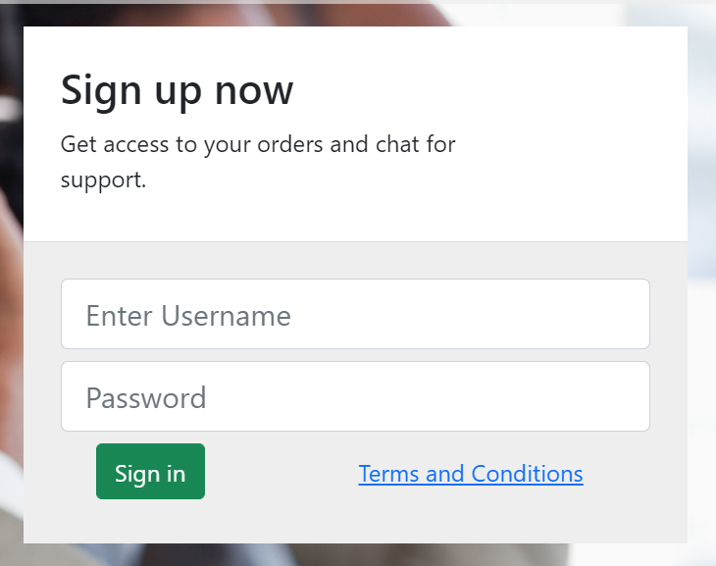

**<Login/> - It will display this.**

**2. Create a table component. Use a javascript array that contains details about a book.**

**Let books = [**

**{**

**Id:”B-001”,**

**Name:”C”,**

**Author:”Kanitkar”,**

**Publication:”World-pub”**

**}**

**]**

**3. Create a component, that will render a div with these styles.**

**Background-color:black**

**Color: white;**

**Font-weight:bold;**

**Margin-bottom:20px;**

**Padding-bottom:30px;**

**Border-radius:50%;**

**Having a doubled border of 5px blue color**